What is a Topology
The physical topology of a network refers to the configuration of cables, computers, and other peripherals. Physical topology should not be confused with logical topology which is the method used to pass information between workstations. The following sections discuss the physical topologies used in networks and other related topics.

Linear Bus
A linear bus topology consists of a main run of cable with a terminator at each end (See fig. 1). All nodes (file server, workstations, and peripherals) are connected to the linear cable.
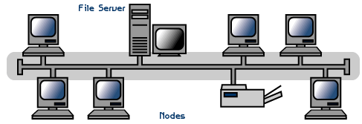
Figure 5-1: Linear Bus topology
Advantages of a Linear Bus Topology
- Easy to connect a computer or peripheral to a linear bus.
- Requires less cable length than a star topology.
Disadvantages of a Linear Bus Topology
- Entire network shuts down if there is a break in the main cable.
- Terminators are required at both ends of the backbone cable.
- Difficult to identify the problem if the entire network shuts down.
- Not meant to be used as a stand-alone solution in a large building.

Star topology
A star topology is designed with each node (file server, workstations, and peripherals) connected directly to a central network hub, switch, or concentrator (See fig. 5-8).
Data on a star network passes through the hub, switch, or concentrator before continuing to its destination. The hub, switch, or concentrator manages and controls all functions of the network. It also acts as a repeater for the data flow. This configuration is common with twisted pair cable; however, it can also be used with coaxial cable or fiber optic cable.
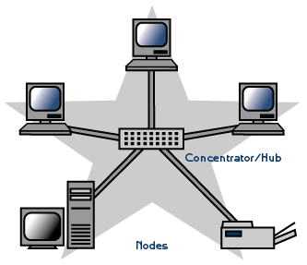
Figure 5-2: Star topology
Advantages of a Star Topology
- Easy to install and wire.
- No disruptions to the network when connecting or removing devices.
- Easy to detect faults and to remove parts.
Disadvantages of a Star Topology
- Requires more cable length than a linear topology.
- If the hub, switch, or concentrator fails, nodes attached are disabled.
- More expensive than linear bus topologies because of the cost of the hubs, etc.

Mesh Network Topology
This is network setup where each computer and network device is interconnected with one another, allowing for most transmissions to be distributed, even if one of the connections go down. This topology is not commonly used for most computer networks as it is difficult and expensive to have redundant connection to every computer. However, this topology is commonly used for wireless networks. Below is a visual example of a simple computer setup on a network using a mesh topology:
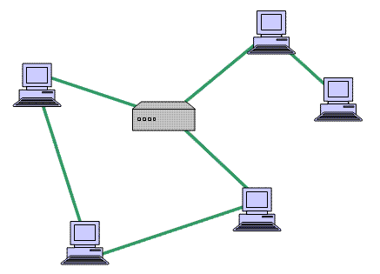
Figure 5-3: Mesh topology

Tree or Expanded Star
A tree topology combines characteristics of linear bus and star topologies. It consists of groups of star-configured workstations connected to a linear bus backbone cable (See fig. 5-10). Tree topologies allow for the expansion of an existing network, and enable schools to configure a network to meet their needs.
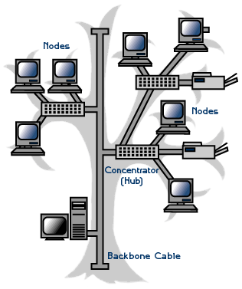
Figure 5-4: Tree topology
Advantages of a Tree Topology
- Point-to-point wiring for individual segments.
- Supported by several hardware and software venders.
Disadvantages of a Tree Topology
- Overall length of each segment is limited by the type of cabling used.
- If the backbone line breaks, the entire segment goes down.
- More difficult to configure and wire than other topologies.

Considerations When Choosing a Topology
- Money. A linear bus network may be the least expensive way to install a network; you do not have to purchase concentrators.
- Length of cable needed. The linear bus network uses shorter lengths of cable.
- Future growth. With a star topology, expanding a network is easily done by adding another concentrator.
- Cable type. The most common cable in schools is unshielded twisted pair, which is most often used with star topologies.

Summary Chart
Physical Topology | Common Cable | Common Protocol
Linear Bus | Twisted Pair  Coaxial  Fiber | Ethernet
Star | Twisted Pair  Fiber | Ethernet
Tree | Twisted Pair  Coaxial  Fiber | Ethernet

Self-evaluation questions
Question one
Using suitable diagrams illustrate the Star, Bus, Ring and Tree topologies (3mks)
List two problems associated with Bus network topology (2mks)
Explain the following with reference to network topologies
RING
STAR
BUS (6 marks)

Question two:
List three differences between Wide Area Network (WAN) and Local Area Networks (LAN) (3Mks)
Name any two media used in guided communication media (2mks)
Briefly describe three benefits of Intranet to a business (3mks)

Question three
Discuss why an organization would want to have a wireless network rather than a cable-based network (15mks)

